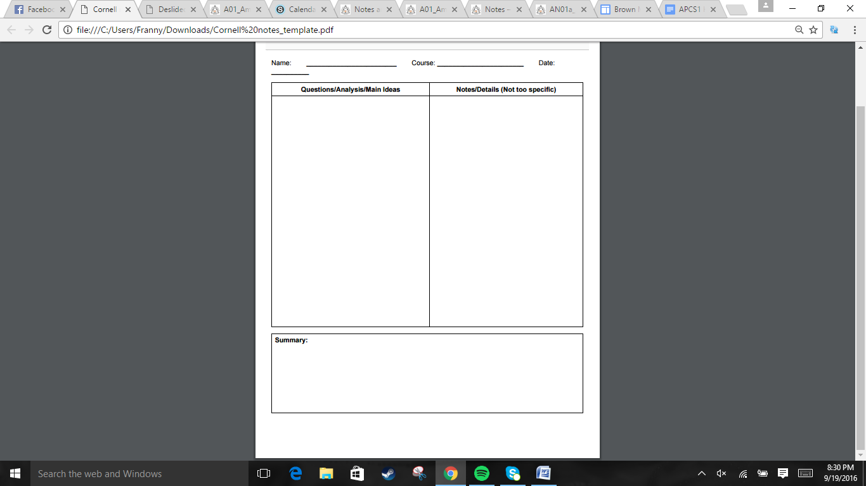  
  
  
  
  
  
  
  
  
  
  
  
  
  
  
  
  
  
  
  
  
  
  
  
  
  
  
  
  
  
  
  
  
  
  
  
  
  
  
  
  


.18th cent Americans believed that democracy placed too much power in uneducated people => favored republics.   
.Most state constitutions limited governmental power and guaranteed certain rights. However, what was defined as a voter varied among states.  
. Representation by population or state? => settled for one representative per state.  
.The Articles of Confederation detailed what the state vs central government could do but the other cannot. These articles were agreed on by all but Maryland, which was concerned with having no land claims. It refused to sign it until March 1781, when all states gave up the land claims.  
.The Land Ordinance of 1785 was made to survey the land given up. The Northwest Ordinance of 1787 detailed how to divide the land into territories and how to admit new states.  
  
. States with less people had the same amount of power as states with more people. Also, a single state could stall an amendment.  
.Congress had 190 mil in debt, and lacked the power to tax  
. Wealthy people who lent money favored high taxes => farmers being in debt => farmers losing their farm  
. Congress could not repay debts to British merchants, Loyalists who lost property, and Spain closed the Mississippi river in 1784, cutting off a crop trade route.

The American colonies used a republic system to govern. The Articles of Confederation were introduced to detail what a state and Congress can and cannot do. All western territory land claims were given up as a result of Maryland, which leads to the Land Ordinance and the Northwest Ordinance. Despite this progress, the states still had many issues.

Jonathan Quang US History 11/9/16

Section 1: Experimenting with Confederation  
How will the states achieve unity?  
  
  
  
What debates occurred regarding the Continental Congress?

What problems did the Confederation encounter?

. James Madison and Alexander Hamilton called for a meeting of state delegates in 1786. Another meeting, with all delegates except Rhode Island was held in Philadelphia in 1787. More delegates showed up due to unrest from events such as Shay's rebellion. Some famous ones were Benjamin Franklin and George Washington, who was elected presiding officer  
. Madison proposed a bicameral legislature based on population size. Paterson suggested a single-house Congress with equal votes per state. Roger Sherman suggested the Great Compromise: Senate has two votes from each state and the House of Representatives based on population.  
.Southern states wanted slaves to count for population, Northern states didn't => 3/5 compromise, a slave counts as 3/5 a person. Congress was also given the power to regulate slave trade, buy only after 20 years  
. The new government was a form of federalism. Power was divided between states and the national government.  
. A system of checks and balances was established between the legislative branch, executive branch, and judicial branch. The incorporation of electoral college also occurred here.  
. The constitution was also provided with a way to amend it.

Section 2: Drafting the Constitution  
Who were the Nationalists that strengthened the government?

What conflicts led to what compromises?  
  
  
  
  
  
  
  
  
How was this new Government under the Constitution organized?

Jonathan Quang US History 11/9/16

Many delegates met up in Philadelphia in 1787 to make the constitution. The result was the Great Compromise, the 3/5 Compromise, checks and balance system between three branches, and electoral college.



. Many Americans were shocked at the radical changes proposed. Ratification would take agreement by at least nine states. Federalists argued that the division of powers and checks and balances was sufficient in protecting Americans from Tyranny. Antifederalists doubted the effectiveness and freedom of the central government.  
. The Federalist, a series of 85 essays defending the Constitution, was written by Hamilton, Madison, and John Jay. Letters from the Federal Farmer was probably written by Richard Henry Lee, read by Antifederalists, which detailed rights that should be protected.  
.The demand for a bill of rights that detailed protected freedoms and rights was so high that the Federalists had to yield and promise to add the bill if the states ratified the Constitution.  
. 9 states had approved of the Constitution by 1788, but the support the two large states, Virginia and New York, was needed anyway. These two states eventually agree, and the new government comes into being in  
 1789.  
.The first 8 amendments of the Bill of Rights discuss personal liberties. 9 & 10 discuss limits on federal government.

Section 3: Ratifying the Constitution  
What role did the Federalists and Antifederalists play in ratifying the Constitution?

How does the Bill of Rights leads to Ratification?

Jonathan Quang US History 11/10/2016

The political battle between Antifederalists and Federalists made the ratification of the US Constitution difficult. The promise of the Bill of Rights led to more supporters of the Constitution. Eventually, it is ratified and the Bill of Rights is also passed.